Categories of software:
System software: programs that manage the computer hardware and the programs that run on them. Examples: operating systems, utility programs, software development tools
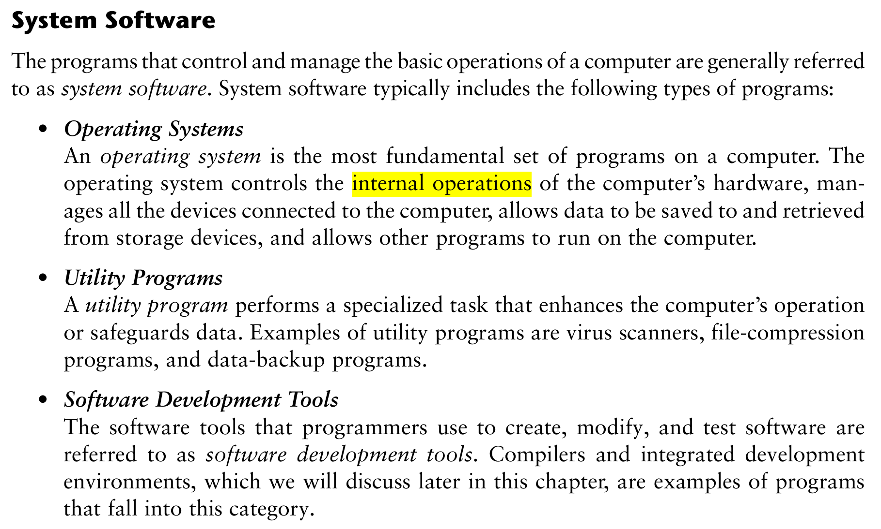
Application software: programs that provide services to the user. Examples : word processing, games, programs to solve specific problems
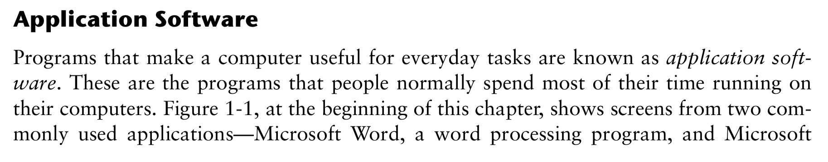
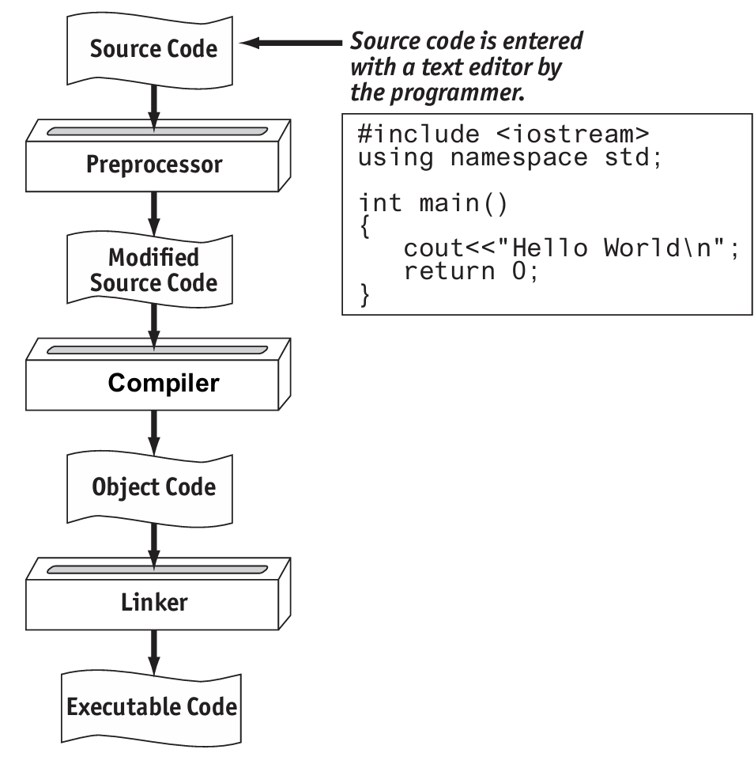
Main memory is commonly known as random-access memory or RAM
A(n) algorithm is an ordered set of steps written in human language to perform a task or to solve any problem.
A program’s ability to run on several different types of computer systems is called portability
Words that have special meaning in a programming language are called Keywords
A(n) compiler translates each source code instruction to the equivalent machine language instruction(s).
Delimiter characters or symbols mark the beginning or end of programming statements, or separate items in a list.
The statement #include is a(n) pre-processor directive
The three primary activities of a program are input, processing, and output.

Chapter2
How many operands does each of the following types of operators require? 1: Unary; 2: Binary; 3: Ternary
Display the values of y and z on the screen. cout << y << " " << z;
Display the number of bytes used by an integer variable. cout << sizeof(int);
11. When you are writing cout, you are using A) a ternary operator B) a library function C) a stream insertion operator D) a stream object
13. The following data 72 'A' "Hello World" 2.8712 are all examples of _________.
A) variables B) literals or constants C) strings D) none of the above
18. How would each of the following numbers be represented in E notation?
A) 3.287 × 106 B) −978.65 × 1012 C) 7.65491 × 10−3 D) −58710.23 × 10−4
A) 3.287E6 B) -9.7865E14 C) 7.65491E-3 D)-5.871023E0
24. T F Variable names may be up to 31 characters long.
- 答案： F (False)
- 知识点解释： C++ 变量名长度通常无严格限制（取决于编译器），但 31 字符是过时的限制。

Chapter3
Write a statement that reads in a string that can contain multiple words separated by blanks. getline(cin, description);
6. 假设程序有以下变量定义：int units; float mass; double weight; 和语句weight = mass * units; 哪个自动数据类型转换会发生？
A) mass demoted to int, units int, result int. B) units promoted to float, mass float, result float. C) units promoted to float, mass float, result double.
答案： C) units promoted to float, mass float, result double.
详细解答： 乘法中，units (int) 提升到float与mass相乘，结果是float，然后赋值给weight (double) 时，float提升到double。
知识点解释： C++的隐式类型转换（promotion）在混合类型运算中发生：低精度向高精度提升（int -> float -> double），避免数据丢失。这确保运算安全，但可能导致精度问题。赋值时也可能转换
12. 写一个cout语句，使变量divSales显示在8空格字段中，在固定点记号中，小数点总是显示，精度为2位小数。
答案： cout << fixed << showpoint << setprecision(2) << setw(8) << divSales;
详细解答： 使用<iomanip>的操纵符：fixed固定小数，showpoint显示小数点，setprecision(2)设置精度，setw(8)字段宽度。
知识点解释： 输出格式化通过操纵符控制，提高显示专业性。需#include <iomanip>和<iostream>。
13. 写一个cout语句，使变量totalAge显示在12空格字段中，在固定点记号中，精度为4位小数。
答案： cout << fixed << setprecision(4) << setw(12) << totalAge;
详细解答： 类似12，但无showpoint（fixed隐含显示小数点如果有小数）。
知识点解释： setprecision控制小数位数，在fixed模式下指定小数点后位数。

14. 变量velocity的值为180.67245612456。写一个cout语句，在6空格左对齐字段中显示它。写另一个cout语句，在18空格字段中显示它，精度为12位小数，在固定记号中，带尾随零。
答案： 第一：cout << left << setw(6) << velocity; 第二：cout << fixed << setprecision(12) << setw(18) << velocity << setfill('0');
详细解答： left左对齐，setw设置宽度。第二个用fixed和setprecision，尾随零可用setfill('0')但通常fixed会显示零，如果需要填充可用。
知识点解释： left/right控制对齐，setfill设置填充字符。精度在fixed下包括尾随零。这用于精确控制输出格式，如报告。
- Stream manipulators are used for formatting the output of a program.
- 知识点: 流操纵器（如 std::setw, std::setprecision）用于控制输出格式，常见于 C++ 的 <iomanip> 头文件。
Hand tracing is a debugging process where you pretend that you are the computer execut ing a program.
The cmath / math.h file must be included in a program that uses the mathematical functions.
Int float double 分别输出什么
#include <iostream>
#include <iomanip>
using namespace std;
int main()
{
long seconds;
double minutes, hours, days, months, years;
cout << "Enter the number of seconds that have\n";
cout << "elapsed since some time in the past and\n";
cout << "I will tell you how many minutes, hours,\n";
cout << "days, months, and years have passed.\n";
cin >> seconds;
minutes = seconds / 60;
hours = minutes / 60;
days = hours / 24;
years = days / 365;
months = years * 12;
cout << setprecision(4) << fixed << showpoint << right;
cout << "Minutes: " << setw(6) << minutes << endl;
cout << "Hours: " << setw(6) << hours << endl;
cout << "Days: " << setw(6) << days << endl;
cout << "Months: " << setw(6) << months << endl;
cout << "Years: " << setw(6) << years << endl;
return 0;
}
Minutes: 612002.0000
Hours: 10200.0333
Days: 425.0014、
Months: 13.9726
Years: 1.1644

